中国·对外经济贸易大学和美国·西雅图城市大学
-
合作举办的工商管理硕士(MBA)项目
招 生 简 章
教育部批准书编号：MOE11US1A20101111N
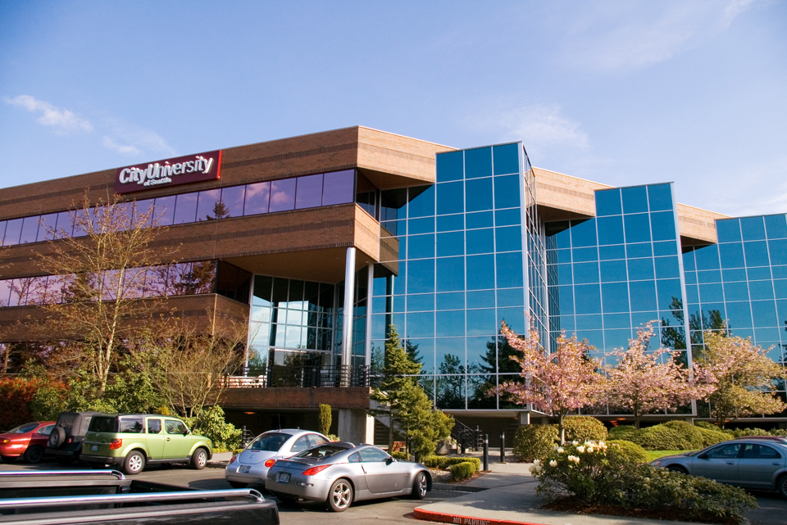
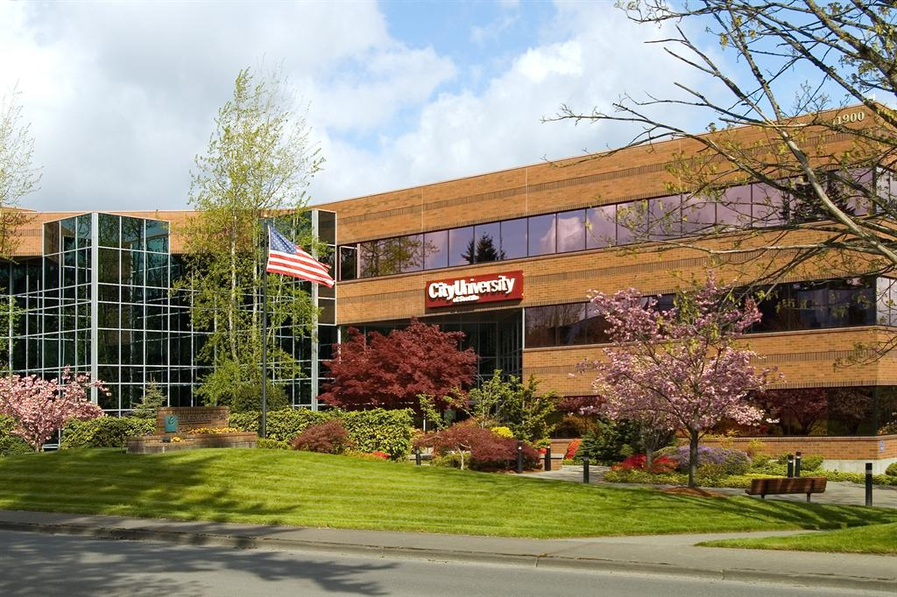

一、中国·对外经济贸易大学（University of International Business and Economics, China）和美国·西雅图城市大学(City University of Seattle, USA)简介
对外经济贸易大学创建于1951年，是教育部直属的全国重点大学，国家 “211工程”首批重点建设高校，拥有经、管、文、法四大学科门类，其国际经济与贸易、法学（国际经济法）、金融学、工商管理、外语（商务外语）等专业，优势明显、特色鲜明。学校现有博士后流动站2个，一级学科博士点4个，二级学科博士点30个，一级学科硕士点7个，二级学科硕士点54个，专业硕士授权点9个，本科专业34个。学校现有教职员工1500人，各类注册学生40,000余人。早在1987年，对外经济贸易大学的国际贸易专业和企业管理专业的硕士学位就被美国纽约州教育厅董事会承认为工商管理硕士（MBA）。
西雅图城市大学（City University of Seattle）成立于1973年，是一所私立、非盈利性的教育机构。它位于美国华盛顿州西雅图市，是美国教育委员会、美国成人和继续教育联合会、美国西北区高校联合会等组织和机构的正式成员，也是美国西海岸最大的私立学校之一，全球注册学生超过13,000名。
该校的工商管理（尤其是行业在职MBA培训）专业和教育管理专业在美国西北部地区均享有很高声誉。据近期美国大学商学院协会调查，西雅图城市大学工商管理专业的学生人数在全美名列前茅，其海外合作项目也得到各国政府权威机构的高度认可。
1995年，西雅图城市大学进入中国以来，就致力于先进的MBA教育，对我国的工商管理硕士教育事业的发展与提升，起到了积极的促进作用，并作为国外优质教育资源，成为首批得到中国教育部认可的美国大学之一。
二、中国·对外经济贸易大学与美国·西雅图城市大学联合举办的MBA项目简介
中国·对外经济贸易大学 —— 美国·西雅图城市大学联合举办的MBA项目是国家教育部正式批准的中外合作办学项目（教育部批准书编号：MOE11US1A20101111N）。 该MBA项目在中国已经合办了15年，培养了1500名任职于跨国公司、政府部门和企事业单位的中高端管理人才，其中包括300多名美国波音公司资助的中国民航系统的在职人员。2004年，该MBA项目曾被《经理人》杂志评选为中国10大联合MBA项目品牌。
本项目实行学分制，总计48个学分，包括15门面授课程以及一份个人商业计划，每门课程面授时间为30小时。教学全部在中国境内完成，授课、教材、教学资料以及作业均以英语完成。

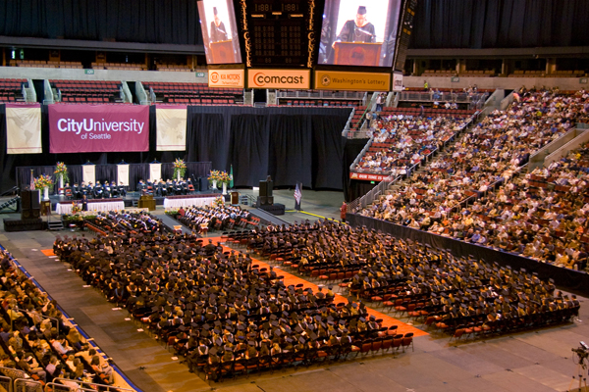

学制及学习方式
学制
15个月
学习方式
本课程项目采取周末半脱产形式，每个月后两个周末在对外经济贸易大学参加由中、美教授直接面授的课程、研讨或讲座，两个周末中间的工作日，担任当月课程的教授会在办公室为同学指导和答疑。

入学资格
大学本科毕业，或大学专科毕业（5年以上工作经验）。
入学考试
正式录取需要通过英语水平考试，可以选择申请Accuplacer考试，或提供国内大学英语六级、专业英语四级证书，或IELTS雅思、TOFEL托福考试成绩。
学位证书
学员修完全部15门课程并且取得G.P.A. 3.0以上，同时完成个人商业计划之后即可申请由美国·西雅图城市大学颁发的工商管理硕士学位证书（MBA）。该学位可获权威认证（中国留学服务中心）和国家承认。
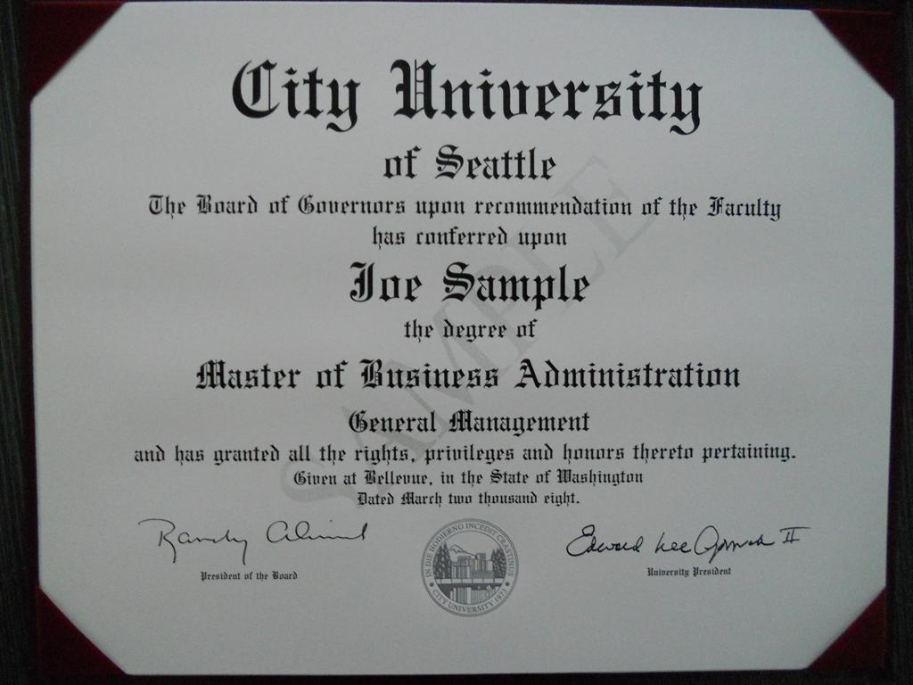
（学位证书样本）

学习费用
学习费用为每人每期人民币159,600元，分学年缴纳。

联系我们 Contact us

联系人：杜老师 联系方式：010-62719327 13121135903

传 真：010-51413865 E-mail：13121135903@qq.com

for office Use only
Student ID #: ___________________________
Date Issued: ___________________________
Application #: __________________________
ApplicAtion
for Admission
city University of seattle
11900 NE First Street
Bellevue, WA 98005
U.S.A.
University of international Business & economics
No. 10, Huixin Dongjie,
Chaoyang District,
Beijing, China
pArt A – stUdent informAtion
1. Name: ________________________________________________________________________________________________________
Last (Family) First Middle
2. Mailing address: ________________________________________________________________________________________________________________________________________
Street/P.O. Box
Apt. Number
City
State/Province
Country
Postal Code
3. Permanent address: ____________________________________________________________________________________________________________________________________
Street/P.O. Box
Apt. Number
City
State/Province
Country
Postal Code
4. Gender: q Male q Female
Date of Birth: ___________________ /___________ /______________ (MM/DD/YYYY)
5. City University of Seattle Student ID # (If none, leave blank) __________________________________________________
6. Current TOEFL or ELTS score available? q Yes q No
(If applicant does not meet the English proﬁciency requirement, student will be required to pass the English placement test prior to starting the program.)
7. Check the quarter you wish to begin:
q Fall
q Winter
q Spring
q Summer
Year __________________
8. Program of Study – master of Business Administration in Global management
pArt B – prior edUcAtion
List only colleges or universities that will supply transcripts to City University of Seattle at your request. Oﬃcial transcripts from these colleges or
universities must be sent to City University of Seattle in sealed institutional envelopes. All transcripts must be oﬃcial (original or certiﬁed copies of
original) documents. Translations, if necessary, must be certiﬁed by the U.S. Consulate, Ministry of Education or the institution itself.
College/University
Location
Attendance
(from - to)
Certiﬁcates/Credits
Degrees Received
Date Transcripts
Requested
Check if
Enclosed
______________________________________________________________________________________________________________________________________ q
______________________________________________________________________________________________________________________________________ q
______________________________________________________________________________________________________________________________________ q
______________________________________________________________________________________________________________________________________ q
In which country did you complete high school? _____________________________________________________________________________________________ q
employment/reimBUrsement informAtion
Are you currently employed?
q Yes q No
Employer ________________________________________________________
Does your employer have a reimbursement program?
q Yes q No
q I don’t know
If Yes, name of reimbursement program _____________________________________________________________________________
SP3237
Page 1

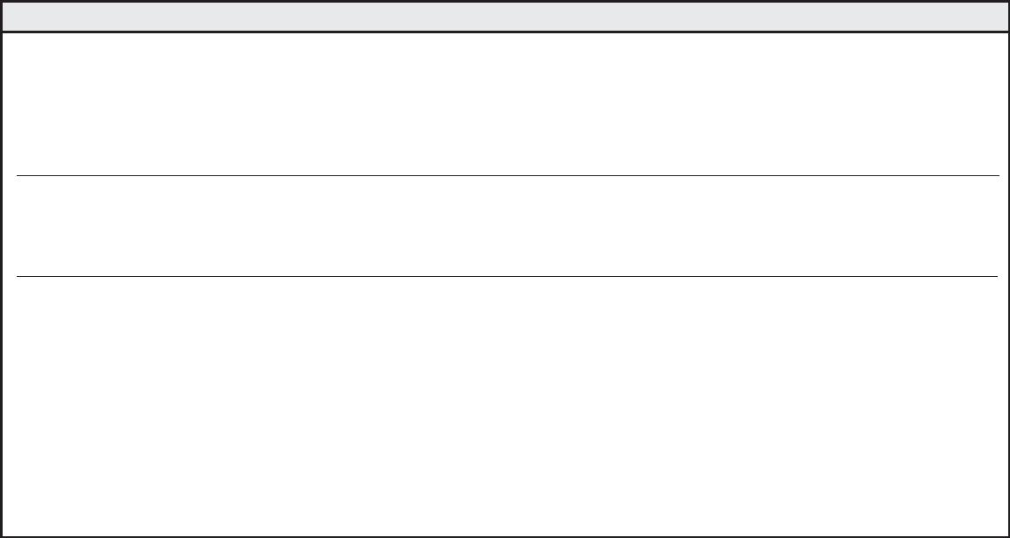
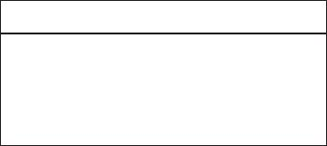






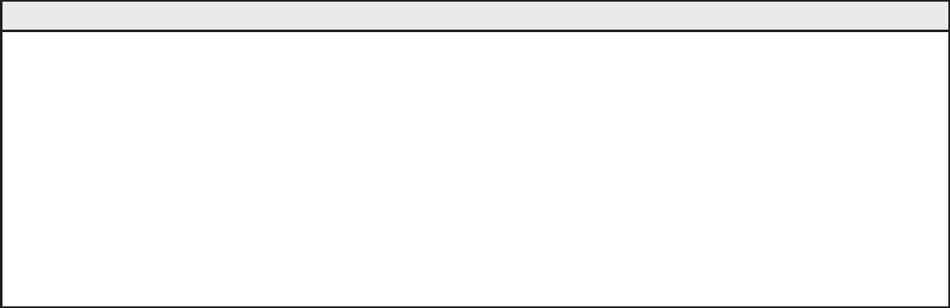
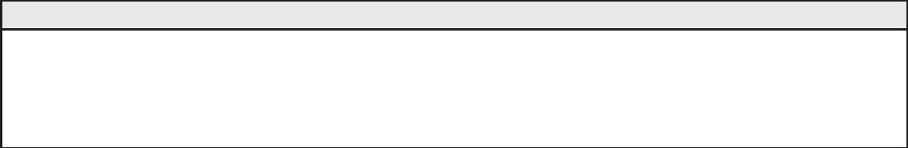


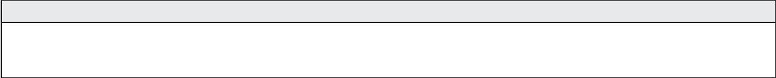
pol ic ies & pr oc edUr es
equal opportunity/non-discrimination Grievance procedure
City University of Seattle subscribes to the principles and laws of individual
states and the federal government, including applicable Executive Orders
that pertain to civil rights, equal opportunity, and aﬃrmative action.
of which the aggrieved party will receive a copy, will be prepared within
10 additional working days for review by the President of the University.
7. When the appropriate action has been determined, all parties
involved will be informed of the decision in writing. Finally, a follow-up
procedure will be developed to ensure the action that was agreed upon
is carried out accordingly.
City University of Seattle prohibits discrimination on the basis of race, gender,
religion, age, national or ethnic origin, physical, mental or sensory disability,
marital status, sexual orientation, and status as a veteran. The policy regulates
the recruitment, employment, and retention of faculty and staﬀand the
operation of all University programs, scholarships, loans, activities, and services.
Documentation of all proceedings will be held in strictest conﬁdence and
maintained in a conﬁdential ﬁle.
It is the responsibility of all City University of Seattle employees to refer
a student grievance to the Director of Human Resources or appropriate
designee for compliance with this procedure.
City University of Seattle has created the following procedure to provide an
eﬀective and acceptable way to bring to the University’s attention any equal
opportunity/non-discrimination, disciplinary or conduct-related problems
and complaints. The procedure helps identify and eliminate legitimate
causes for dissatisfaction and enables students, faculty and staﬀ to ﬁle a
grievance without fear of retribution or prejudice. The procedure is separate
from and applies to all issues other than grades.
substance Abuse policy
The goal of City University of Seattle’s substance abuse policy is to ensure
that the University and all its locations are free of illegal drug use, alcohol
abuse or illegal drug activity. All City University of Seattle employees, faculty,
staﬀ and students will be provided with a complete copy of this policy.
From time to time, drug-related educational materials and programs will be
oﬀered to enhance your awareness of the facts about alcohol abuse, as well
as illegal drugs and the consequences of their use. Materials and programs
also will describe the alternatives available to you in the event that you
are or may become involved with drugs and feel the need for professional
assistance. The University’s typical response to voluntary requests for
assistance is summarized in the policy. The policy’s legal basis is the Federal
Drug-Free Workplace Act of 1988, and Drug-Free School and Com munities
Act-Higher Education, Drug-Free Schools and Campuses, August 16, 1990.
These laws and this policy apply to all City University of Seattle employees,
faculty, staﬀ and students, full-time, part-time and on-call. City University
of Seattle is required by strict mandate of the Department of Education to
implement and enforce these regulations.
Evidence of practices that are inconsistent with this policy should be
reported to the Human Resources Oﬃce. If a situation warrants further
administrative assistance, after using City University of Seattle’s grievance
procedure and appeals conciliation process, public resources are available
through the U.S. Department of Education, the U.S Oﬃce of Civil Rights, and
the Washington State Human Rights Commission.
t he grievance ﬁling procedures are as follows:
1. The aggrieved party contacts the Director of Human Resources or
appropriate designee as soon as a problem is recognized.
2. The aggrieved party and the Director of Human Resources or
appropriate designee meet where an appropriate form is provided for
the aggrieved party.
3. Once the form is completed, the Director of Human Resources or
appropriate designee conducts an investigation and prepares a report
of ﬁndings.
disclosure of c ampus security policy & c ampus c rime statistics Act
City University of Seattle is a private nonproﬁt institution of higher education.
Its mission to provide educational opportunities world wide, prima rily
to segments of the population not being fully served. City University of
Seattle is committed to the safety and security of its entire faculty, staﬀ and
students. In accordance with the Jeanne Clery Disclosure of Campus Security
Policy and Campus Crime Statistics Act, the university is dedicated to the
accurate and timely dissemination of all crime statistics and security related
information to our constitu ents. The annual report containing campus
and non-campus crime statistics and related information may be accessed
at www.cityu.edu. Paper copies are available upon request by calling our
Human Re source Department at 1.800.426.5596, extension 7613.
4. The Director of Human Resources or appropriate designee reviews
the ﬁndings with the aggrieved party’s department head and the
University’s management team.
5. Within 10 days the outcome of these reviews will be shared with the
aggrieved party.
6. In the event of any apparently irreconcilable conﬂict, a three-person
board comprised of non-involved management, supervisory staﬀ and a
member of one’s peer group will be appointed to review the grievance
and attempt conciliation. The board’s written recommendation,
eq UAl oppor t Un it y, dr UG An d Gr iev An c e pol ic ies
By signing this form I conﬁrm that have read and understand the above equal opportunity, drug, grievance, and campus security policy statements.
please initial and date _________________________________________
s pec iAl Ac c ommodAt ion s
Do you require special accommodation? q Yes q No If yes, please contact the Disability Resource Oﬃce at 800.426.5596 ext. 7620
I hereby certify that the information I have provided on this application is accurate and complete to the best of my knowl edge. I acknowledge that the
falsiﬁcation of information of information on the application or other required documents will result in the dismissal from the university.
q I hereby authorize City University of Seattle to release my information about my records to: University of international Business & economics
Student Name (please print) _______________________________________________________________________________________
Student Signature ___________________________________________________________________ Date _______________________
How did you hear about us?
q Family/Friends q Student Fair q Internet q Publication q Other__________________
SP323
Page 2

