北京对外经贸大学与美国马里兰大学领导力EMBA

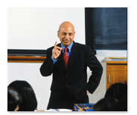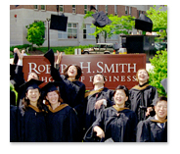
来自世界一流大学的高级工商管理课程（简称EMBA课程）日益获得中国高级管理人员的青睐！但是对于正处在事业上升期的职业经理人来说，谁愿意辞去工作，用两年的时间与金钱远赴海外去专门学习这一课程呢？美国马里兰大学在中国开展的领导力EMBA项目帮助您在保证工作的同时也能获得来自美国名校的工商管理硕士学位！
美国马里兰大学领导力EMBA项目是马里兰大学史密斯商学院与对外经贸大学合作推出的高级工商管理课程。课程将美国的纯正的商业管理理论、案例及商业文化带到了中国，着眼于培养商业领袖的战略视野与全面管理企业的能力，将掌控力、领导力、行动力学习与赴美学习体验这四个核心要素与基础的核心课程有机的结合起来，关注革新与创业精神，形成了一套培养杰出领导力的综合方法。
经教育部批准的中外合作办学项目，毕业生获得美国马里兰大学史密斯商学院颁发的工商管理硕士（MBA）学位证书，可在教育部留学服务中心获得认证。和对外经贸大学国际商学院颁发的管理学进修证书
聚焦跨区域的创新与领导力的高端课程，使用与史密斯商学院美国国内高端课程相同的教学理念与师资。
课程共有54个学分，历时18个月，每月连续四天（周四至周日）集中在京上课。
一年一个班 学费：45，5000元
建立于1856年的美国马里兰大学目前跻身美国研究型公立大学前二十位。美国马里兰大学帕克校区紧邻美国首都华盛顿，与华盛顿有着广泛而深入的政治、经济联系。在上海交通大学公布的2012年经济学/商学领域的世界百强学校评比中，美国马里兰大学位列第23位。马里兰大学史密斯商学院是帕克校区的13所学院之一，是国际公认的管理教学和数字经济研究的领导者，提供本科，全日制和非全日制MBA，EMBA，博士和主管培训等教育项目。
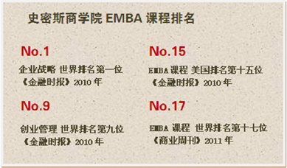
目前北京地区唯一一个排名世界前列的美国高级工商管理课程项目。
与美国本部相同的教授，课程，学习材料与学位证书，学费比美国本部同样的项目少了20余万人民币。
最后一门总结课程在美国马里兰大学本部和美国首都华盛顿特区展开，您将获得实地了解美国经济和政治面貌的机会。
无需 GMAT和 TOEFL 等英语语言测试，由校方进行面试录取。
 | 核心课程： | 高阶课程：
 | 高级管理财务 | 品牌管理
 | 竞争，战略与全球化 | 企业社会责任
 | 数据模型与决策 | 执行力与谈判
 | 金融管理 | 全球创业管理与革新
 | 全球商业环境 | 实施战略
 | 领导力与人力资源 | 国际金融
 | 领导力发展
 | 市场营销战略
 | 运营管理
 | 战略与转型的信息技术
 | 物流与供应链管理
7年以上工作经验
4年以上管理工作经验
拥有学士学位
较好的英语语言能力
师资介绍：
美国马里兰大学领导力 EMBA 项目的所有授课老师是美国马里兰大学史密斯商
学院的全职教师，他们在美国马里兰大学史密斯商学院本部教授MBA 和EMBA
课程。美国马里兰大学史密斯商学院的学术研究在2013 年的《金融时报》上跻
身全球第15 位，这是对美国马里兰大学史密斯商学院师资实力的充分肯定。
以下列举几位美国马里兰大学领导力 EMBA 项目中授课的老师：

Dr. Gupta is the Michael Dingman Chair in Strategy and
Globalization at The University of Maryland and a Visiting
Professor at INSEAD. The author of five books and over 70
highly cited academic papers, he also serves as a regular
columnist for Bloomberg BusinessWeek. His book, Getting
China and India Right: Leveraging the World's
Fastest-Growing Economies for Global Advantage (Wiley,
2009), received the 2009 Axiom Book Awards' Silver Prize as
one of the world's two best books on globalization and international business. He is
also the co-author of The Quest for Global Dominance (Wiley, 2008), a highly
acclaimed book on global strategy.
Widely regarded as a leading expert on strategy, globalization, and emerging markets,
Dr. Gupta was recognized by The Economist as one of the world's "rising superstars" in
a cover story on "Innovation in Emerging Economies." He is a regular participant in the
World Economic Forum’s summits including the annual meeting in Davos and is a
member of the Forum’s Global Agenda Council on Emerging Multinationals. Dr.
Gupta is one of only three professors in the world to have been elected by his peers as a
Lifetime Fellow of all three of the most prestigious academic bodies in the field –
Academy of Management, Strategic Management Society, and Academy of
International Business, with a combined membership of over 25,000 scholars
worldwide. He has also been inducted into the Academy of Management Journals' Hall
of Fame and ranked by Management International Review as one of the "Top 20 North
American Superstars" for research in strategy and organization. He also received the
"2010 Best Professor in Strategic Management Award" from CMO Asia.
Dr Gupta has also been interviewed and quoted by The Economist, The Wall Street
Journal, The Washington Post, Bloomberg BusinessWeek, CNBC, BBC, The Daily
Telegraph, China Daily, The Economic Times, and other leading media. He received a
doctorate from the Harvard Business School, an MBA from the Indian Institute of
Management at Ahmedabad and a B.Tech. from the Indian Institute of Technology at
Kanpur.
Russell is a licensed industrial and organizational
psychologist and has over 25 years of experience consulting
with both private and public sector organizations. Her
expertise is primarily in the areas of leadership and
management development, negotiation tactics, executive
coaching and change management. Some of her clients have
included: Lockheed Martin, Marriott, Department of
Defense, Oak Ridge National Laboratory, National Institute
of Health, SAIC, Frito-Lay, Quaker Oats, M&M Mars,
ALCOA, Entergy, Yodlee, Black & Decker, Boeing Corporation, Hughes
Communications, McCormick, Sprint/Nextel, Tennessee Valley Authority, State of
Tennessee, Bell-South, L.M. Berry & Company, and Bryce Corporation.
Since joining the UMD faculty, she has consistently been honored for being one of
the outstanding (Top 15%) teachers. She has also been selected three times for the
Allen J. Krowe Award for Teaching Excellence given for outstanding teaching among
tenured, tenure-track, and teaching professors.
Prior to joining UMD, she was a tenured full professor in the College of Business
Administration at the University of Tennessee. At UT, she received numerous
teaching and research awards from students and faculty for her work with Executive
MBAs, MBAs, doctoral students, and undergraduates. Some of them include: The
University of Tennessee National Alumni Association Outstanding Teaching Award,
the College of Business Administration’s John B. Ross Award for Outstanding
Teaching among senior, tenured professors, the Tennessee Organization of MBAs
Outstanding Teaching Award, the UT Chancellor’s Award for Excellence in Team
Development and Team Teaching of the Integrated MBA Curriculum, and the College
of Business Administration’s William B. Stokely Research/Teaching Scholar Award,
among others.
Russell has published over 50 articles, books, or book chapters and has presented her
research at national and regional conferences. She served as the associate editor for
the Journal of Vocational Behavior, and on the editorial boards of the Journal of
Applied Psychology, Human Resource Management Review, and Performance
Improvement Quarterly. She received her PhD in Industrial and Organizational
Psychology from the University of Akron, Ohio and her BA degree in psychology
from Loyola College in Maryland.
Dr. Brent Goldfarb is Associate Professor of Management
and Entrepreneurship in the M&O Department at the
University of Maryland's Robert H. Smith School of
Business. Goldfarb's research focuses on how the production
and exchange of technology differs from more traditional
economic goods, with a focus on the implications on the role
of startups in the economy. He focuses on such questions as
how do markets and employer policies affect incentives to
discover new commercially valuable technologies and when is it best to
commercialize them through new technology-based firms? Why do radical
technologies appear to be the domain of startups? And how big was the dot.com boom?
Copies of Dr. Goldfarb's publications and working papers have been downloaded over
1200 times.
Primary Research Areas:
▪ Technological Entrepreneurship
▪ Technological Change & Policy
▪ Applied Econometrics
▪ Industrial Organization
▪ Economic & Business History
▪ Science Policy
Rebecca Hann received her MA and PhD from the Wharton
School of the University of Pennsylvania. Her research
examines issues surrounding financial reporting and
disclosure, corporate diversification, and more recently, the
role of accounting information in the macroeconomy. Her
research has been published in leading accounting and
finance journals, including the Accounting Review, the
Journal of Accounting and Economics, the Journal of
Accounting Research, the Journal of Finance, and the Review of Accounting Studies.
Prior to joining the Smith School, she was on the faculty of the University of Southern
California's Marshall School of Business.

联系我们 Contact us

联系人：杜老师 联系方式：010-62719327 13121135903
传 真：010-51413865 E-mail：13121135903@qq.com







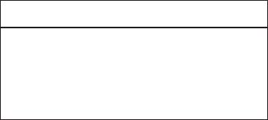

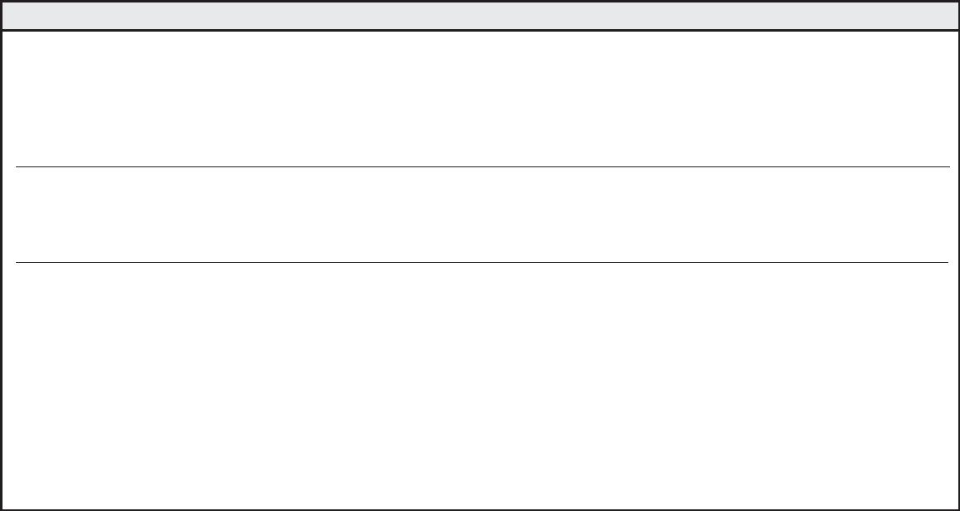

for office Use only
Student ID #: ___________________________
Date Issued: ___________________________
Application #: __________________________
ApplicAtion
for Admission
city University of seattle
11900 NE First Street
Bellevue, WA 98005
U.S.A.
University of international Business & economics
No. 10, Huixin Dongjie,
Chaoyang District,
Beijing, China
pArt A – stUdent informAtion
1. Name: ________________________________________________________________________________________________________
Last (Family) First Middle
2. Mailing address: ________________________________________________________________________________________________________________________________________
Street/P.O. Box
Apt. Number
City
State/Province
Country
Postal Code
3. Permanent address: ____________________________________________________________________________________________________________________________________
Street/P.O. Box
Apt. Number
City
State/Province
Country
Postal Code
4. Gender: q Male q Female
Date of Birth: ___________________ /___________ /______________ (MM/DD/YYYY)
5. City University of Seattle Student ID # (If none, leave blank) __________________________________________________
6. Current TOEFL or ELTS score available? q Yes q No
(If applicant does not meet the English proﬁciency requirement, student will be required to pass the English placement test prior to starting the program.)
7. Check the quarter you wish to begin:
q Fall
q Winter
q Spring
q Summer
Year __________________
8. Program of Study – master of Business Administration in Global management
pArt B – prior edUcAtion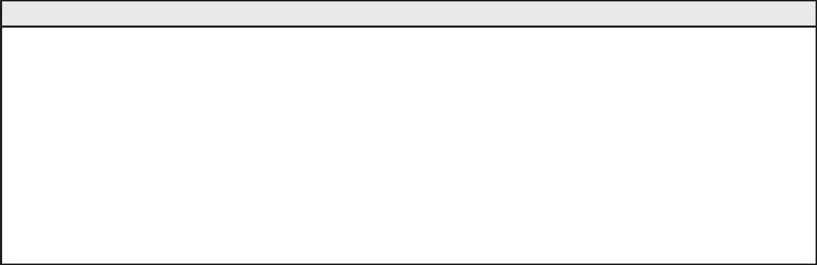
List only colleges or universities that will supply transcripts to City University of Seattle at your request. Oﬃcial transcripts from these colleges or
universities must be sent to City University of Seattle in sealed institutional envelopes. All transcripts must be oﬃcial (original or certiﬁed copies of
original) documents. Translations, if necessary, must be certiﬁed by the U.S. Consulate, Ministry of Education or the institution itself.
College/University
Location
Attendance
(from - to)
Certiﬁcates/Credits
Degrees Received
Date Transcripts
Requested
Check if
Enclosed
______________________________________________________________________________________________________________________________________ q
______________________________________________________________________________________________________________________________________ q
______________________________________________________________________________________________________________________________________ q
______________________________________________________________________________________________________________________________________ q
In which country did you complete high school? _____________________________________________________________________________________________ q
employment/reimBUrsement informAtion
Are you currently employed?
q Yes q No
Employer ________________________________________________________
Does your employer have a reimbursement program?
q Yes q No
q I don’t know
If Yes, name of reimbursement program _____________________________________________________________________________
SP3237
Page 1

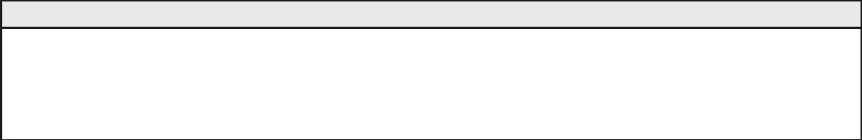


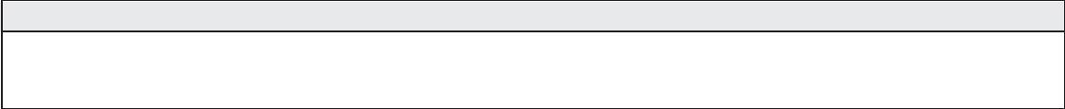
pol ic ies & pr oc edUr es
equal opportunity/non-discrimination Grievance procedure
City University of Seattle subscribes to the principles and laws of individual
states and the federal government, including applicable Executive Orders
that pertain to civil rights, equal opportunity, and aﬃrmative action.
of which the aggrieved party will receive a copy, will be prepared within
10 additional working days for review by the President of the University.
7. When the appropriate action has been determined, all parties
involved will be informed of the decision in writing. Finally, a follow-up
procedure will be developed to ensure the action that was agreed upon
is carried out accordingly.
City University of Seattle prohibits discrimination on the basis of race, gender,
religion, age, national or ethnic origin, physical, mental or sensory disability,
marital status, sexual orientation, and status as a veteran. The policy regulates
the recruitment, employment, and retention of faculty and staﬀand the
operation of all University programs, scholarships, loans, activities, and services.
Documentation of all proceedings will be held in strictest conﬁdence and
maintained in a conﬁdential ﬁle.
It is the responsibility of all City University of Seattle employees to refer
a student grievance to the Director of Human Resources or appropriate
designee for compliance with this procedure.
City University of Seattle has created the following procedure to provide an
eﬀective and acceptable way to bring to the University’s attention any equal
opportunity/non-discrimination, disciplinary or conduct-related problems
and complaints. The procedure helps identify and eliminate legitimate
causes for dissatisfaction and enables students, faculty and staﬀ to ﬁle a
grievance without fear of retribution or prejudice. The procedure is separate
from and applies to all issues other than grades.
substance Abuse policy
The goal of City University of Seattle’s substance abuse policy is to ensure
that the University and all its locations are free of illegal drug use, alcohol
abuse or illegal drug activity. All City University of Seattle employees, faculty,
staﬀ and students will be provided with a complete copy of this policy.
From time to time, drug-related educational materials and programs will be
oﬀered to enhance your awareness of the facts about alcohol abuse, as well
as illegal drugs and the consequences of their use. Materials and programs
also will describe the alternatives available to you in the event that you
are or may become involved with drugs and feel the need for professional
assistance. The University’s typical response to voluntary requests for
assistance is summarized in the policy. The policy’s legal basis is the Federal
Drug-Free Workplace Act of 1988, and Drug-Free School and Com munities
Act-Higher Education, Drug-Free Schools and Campuses, August 16, 1990.
These laws and this policy apply to all City University of Seattle employees,
faculty, staﬀ and students, full-time, part-time and on-call. City University
of Seattle is required by strict mandate of the Department of Education to
implement and enforce these regulations.
Evidence of practices that are inconsistent with this policy should be
reported to the Human Resources Oﬃce. If a situation warrants further
administrative assistance, after using City University of Seattle’s grievance
procedure and appeals conciliation process, public resources are available
through the U.S. Department of Education, the U.S Oﬃce of Civil Rights, and
the Washington State Human Rights Commission.
t he grievance ﬁling procedures are as follows:
1. The aggrieved party contacts the Director of Human Resources or
appropriate designee as soon as a problem is recognized.
2. The aggrieved party and the Director of Human Resources or
appropriate designee meet where an appropriate form is provided for
the aggrieved party.
3. Once the form is completed, the Director of Human Resources or
appropriate designee conducts an investigation and prepares a report
of ﬁndings.
disclosure of c ampus security policy & c ampus c rime statistics Act
City University of Seattle is a private nonproﬁt institution of higher education.
Its mission to provide educational opportunities world wide, prima rily
to segments of the population not being fully served. City University of
Seattle is committed to the safety and security of its entire faculty, staﬀ and
students. In accordance with the Jeanne Clery Disclosure of Campus Security
Policy and Campus Crime Statistics Act, the university is dedicated to the
accurate and timely dissemination of all crime statistics and security related
information to our constitu ents. The annual report containing campus
and non-campus crime statistics and related information may be accessed
at www.cityu.edu. Paper copies are available upon request by calling our
Human Re source Department at 1.800.426.5596, extension 7613.
4. The Director of Human Resources or appropriate designee reviews
the ﬁndings with the aggrieved party’s department head and the
University’s management team.
5. Within 10 days the outcome of these reviews will be shared with the
aggrieved party.
6. In the event of any apparently irreconcilable conﬂict, a three-person
board comprised of non-involved management, supervisory staﬀ and a
member of one’s peer group will be appointed to review the grievance
and attempt conciliation. The board’s written recommendation,
eq UAl oppor t Un it y, dr UG An d Gr iev An c e pol ic ies
By signing this form I conﬁrm that have read and understand the above equal opportunity, drug, grievance, and campus security policy statements.
please initial and date _________________________________________
s pec iAl Ac c ommodAt ion s
Do you require special accommodation? q Yes q No If yes, please contact the Disability Resource Oﬃce at 800.426.5596 ext. 7620
I hereby certify that the information I have provided on this application is accurate and complete to the best of my knowl edge. I acknowledge that the
falsiﬁcation of information of information on the application or other required documents will result in the dismissal from the university.
q I hereby authorize City University of Seattle to release my information about my records to: University of international Business & economics
Student Name (please print) _______________________________________________________________________________________
Student Signature ___________________________________________________________________ Date _______________________
How did you hear about us?
q Family/Friends q Student Fair q Internet q Publication q Other__________________
SP323
Page 2

