对外经济贸易大学中法国际工商管理学院
Sino-French school of International Management
法国巴黎一大（索邦大学）
UNIVERSITY PARISＩ(SORBONNE UNIVERSITY)
在职班 MBA项目
Part Time MBA Program
为什么申请此项目？Why this program？
- 历史长 Long History

1991年在中法政府支持下创办，国内最早的中外合作MBA项目之一。
Under the support of both Chinesse and French governement, this Sino-French MBA programe by UIBE was estabished in 1991, and was one of the earliest joint MBA programs in China.

- 高效率Efficient Learning

十八个月打造专业及语言优势，适度紧凑的管理课程助力商道攻略。
18-month intensive study to create business professionalism and foreign language abilities

- 国际性Internationalism

巴黎一大研修部分课程，亲处巴黎文化氛围；师从国际知名教授，融入国际校友网络，拓展职业发展空间。
Courses at University Paris I (Sorbonne University) and given by the world-class professors enable students to experience French culture, to be part of an international alumni network, and to enhance professional competitiveness.

- 强品牌Brand Influence

中外名校联袂打造，高质量管理课程助您驰骋职场！
Cooperation between prestigious universities in France and China guarantees the program’s high quality.

- 双学位Dual-degree opportunity

获巴黎一大学位及对外经济贸易大学企业管理硕士结业证书，符合条件者可以申请我国同等学力企业管理硕士学位。
The program provides—A Degree of Master of Business Administration from the University Paris I (Sorbonne University), and A Certificate of MBA course from UIBE (to apply for a master’s degree by finishing additional courses)

谁可以申请此项目？Who are our candidates ?

- 具有学士学位 Graduates with a bachelor’s degree.
- 具有至少三年以上的工作经验 With minimum 3 years’working experience
注：大专（三年制）毕业生需要至少五年以上的工作经验
Note : Junior college (three-year schooling) graduates without bachelor’s degree can apply, provided they have at least 5 years’ working experience.The acceptance of their application will be assessed by the selection committec.
- 英语熟练 English language proficiency

在哪里上课？Where to have class ?

中国对外经济贸易大学，法国巴黎一大，企业移动课堂
Uniersity of International Business and Economics, Paris I , Enterprise Mobile Classroom.

学制：18个月；学费：人民币150，000元；

入学考试形式？What kind of exams ?

笔试 Test

英语自命题，形式参考GMAT模式
A test in English similar to GMAT is arranged by IFCM.
注：GMAT成绩550分以上者可申请免试
Note: Candidates who get more than 550 in GMAT can apply for the test exemption.

面试 Interview

面试小组由中法双方教授及企业代表组成，以英语进行，重点考察应试者的工作经历和个人发展潜力。
An admission committee comprising Chinese and French professors and corporate representatives will evaluate the applicant’s working experience and career potential. The interview is conducted in English.

如何申请？How to apply the program?

*申请者提交申请材料Submission of application materials

*学院进行资格审核 Initial review and evaluation

*考生参加入学考试 Take IFCM entrance examination

*考生参加面试 Interview

*录取学生Enrollment

*学院发送入学通知 Admission Notification

*被录取者确认报到 Enrollment Confirmation

申请材料有哪些？ What application materials you need provide?

申请表（电子版和打印版）
学位证书复印件及学历证书复印件
身份证复印件（中国学生）或者护照（国际学生）复印件
毕业学校官方开具的成绩单
中文版和英文版简历
3张一寸免冠照片及其相应电子版（正装蓝底免冠）
其他材料（包括专业证书，获奖证书等）
A complete application package should include the following:
Application Form (Electronic version and paper version)
Photocopy of degree certificates
Photocopy of ID (mainland China students) or passport (international students)
Official university transcript in English
CV in Chinese and English
Three passport-sized color photos
Other supporting documents (e.g. copies of professional certificates, awards, honors)

开设什么课程？What subjects do we offer ?

商务导论
Introduction to Business
商务决策的定量方法学
Quantitative Methods for Business Decisions
经济学与欧洲商务
Economics and European Business
企业法律环境
Legal Environment of Business
营销管理
Marketing Management
会计
Accounting
生产与运营管理
Process and Operations Management
公司理财
Corporate Finance
人力资源管理与组织行为学
Human Resources Management&Organizational Behavior
管理会计
Managerial Accounting
销售团队管理
Sales Force Management
管理数字化公司
Managing the Digital Firm

金融市场

Financial Markets
战略管理与组织结构
Strategic Management and Organizational Structure
论文答辩
Thesis Preparation

联系我们 Contact us

联系人：杜老师 联系方式：010-62719327 13121135903
传 真：010-51413865 E-mail：13121135903@qq.com

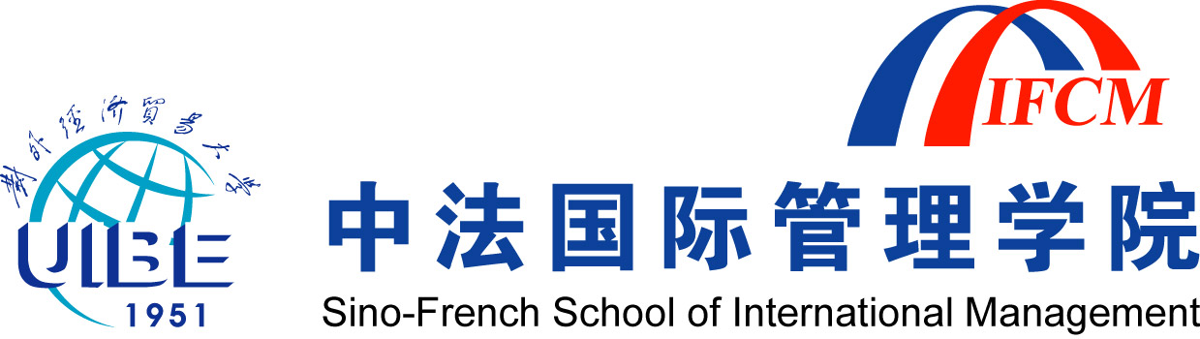
IFCM MBA Program Application Form for Students 2014
※Please use English to complete all sections in the form.
请用英文填写

1. Personal Information个人信息 |  |  | Attach photo here  在此贴照片
Full Name姓名（中英文） |  |  | Attach photo here  在此贴照片
Date of Birth生日____/____/19____ (mm/dd/yy) |  |  | Attach photo here  在此贴照片
  Sex性别 | □Male男 □Female女
Nationality国籍 | Place of Birth出生地 | Type of Study参加学习类别  □Full-time □Part-time | Attach photo here  在此贴照片
Native Language(s)母语 | Other Languages其它语言 | ID or Passport Number身份证或护照号
Current Employment and Job Description
现工作单位及职务、职称（此项用中文填写）

2. Contact Information联系方式
Telephone  电话 | Cell Phone  手机
Fax  传真 | E-mail
Mail Address
邮政地址及编码

3. Higher Education Background高等教育背景
Name of University学校名称 | Major专业 | Degree学位 | From mm/yy to mm/yy从何年月至何年月

Note备注:
- Please provide 3 1-inch ‘standard’ photos at the time of registration for the purpose of entrance exam.报名时请提供三张一寸免冠照片，供办理准考证用；
- Please provide one copy of your diploma, ID card, transcript and certificate of CET4 or 6(other certificates for your English level), curriculum vitae in Chinese and in English, together with 300 Yuan RMB for entrance examination. Please show originals of the aforesaid at the registrar’s office. 报名时请提供详细的个人信息：大学毕业证书、学位证书、成绩单（附四、六级外语证书或其他考试成绩证明）、中、英文简历及身份证复印件、考试费300元人民币。考试报到时须出示上述证件原件。
4. Work and Educational Background学习及工作经历

Please fill out this part of form in details (in English).

5. Statement of Purpose学习动机陈述

In the space below, please indicate in English your motives and plans for studying at IFCM.

